Generación del 98 [Generation of ´98]

The Generation of ´98, a Spanish literary and cultural movement of the first two decades of the 20th century, was a group of writers, poets, and intellectuals born between 1864 and 1876, who were against both the politics of the conservative ruling class, as well as the principle of Realism as postulated by the likes of Benito Pérez Galdós and José Echegaray in the literary scene of Madrid at the end of XIX century.

The Generation of ´98 was deeply affected by the moral, political, and social crisis after Spain’s military defeat in the Spanish-American War of 1898 in which Spain lost Puerto Rico, Guam, Cuba, and the Philippines, which meant the end of the Spanish empire. This historic event, along with the effects of a contra-reformist Catholic Church, further aggravated the national situation, highlighting the profound social crisis and creating a cultural stagnation that left the country in a state of defeat and decline at the very moment Europe was experiencing an accelerated shift in terms of modernity.

In this historical context and cultural stagnation, the Generation of ´98 broke radically with the canon of the nineteenth-century in an attempt at literary renewal. They seek inspiration in European modernism, particularly in French symbolism and Schopenhauer’s pessimism, who postulated in *The World as Will and Representation* (1818) that harmony and peace can only be achieved by eliminating desire, but still, this is only possible with an ascetic way of life and death. The group was concerned with reconstructing the national identity by searching for the essential characteristics in Spanish history and culture, and within the austere Castilian way of life. Here is where many of them discovered the essence of Hispanicism, rejecting the aesthetics of Realism. However, these authors, departing from the so-called “Group of Three” (Pío Baroja, Azorín, and Ramiro de Maeztu), began to write in a critical and radical manner that would later return to a traditional conception of the old and the new, embracing the thesis of Regenerationism as a scientific and objective approach of analysing the decline of the Spanish nation.

The Generation of ‘98 was not an organised group, but rather they were given this name by critics later on. José Martínez Ruiz, using the pseudonym Azorín, was the first that used the namein his essay “La generación de 1898” (1913) triggering a polemic in the literary scene of the time. Baroja and Maetzu denied the existence of such a generation, but others such as Pedro Salinas affirmed it after a thorough investigation. On the other hand, José Ortega y Gasset distinguished two generations around dates 1857 and 1872, one consisting of Ganivet and Unamuno, and another group of younger members. However, his disciple Julián Marías, combining the concept of "historical generation" and the year of 1871, declared that the Generation of '98s members were Miguel de Unamuno, Ángel Ganivet, Valle-Inclán, Jacinto Benavente, Carlos Arniches, Vicente Blasco Ibáñez, Gabriel y Galán, Manuel Gómez-Moreno, Miguel Asín Palacios, Serafín Álvarez Quintero, Pío Baroja, Azorín, Joaquín Álvarez Quintero, Ramiro de Maeztu, Manuel Machado, Antonio Machado y Francisco Villaespesa, being Unamuno and Antonio and Manuel Machado unanimously accepted as the most accomplished authors of the group.

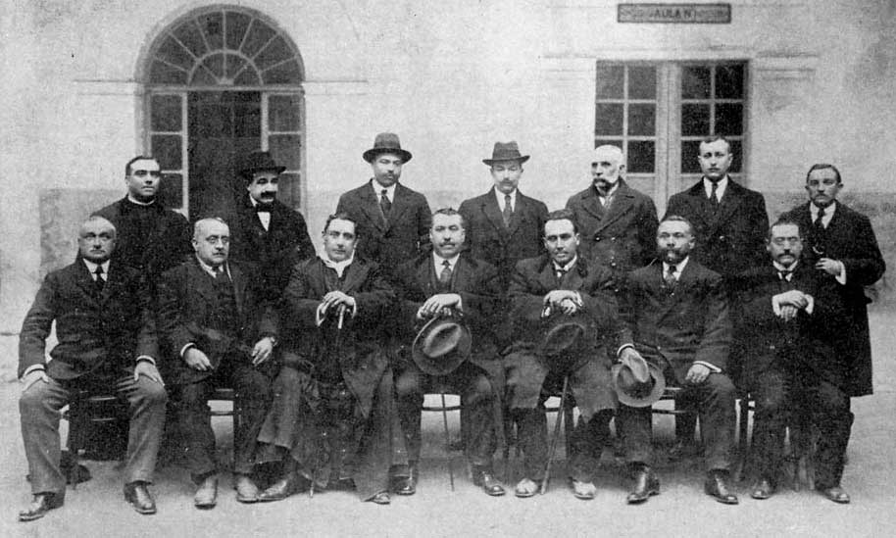

Photo: www.spanish-art.org

**References and Further Readings:**

Barton, Simon (2009). *A History of Spain*. Palgrave Macmillan.

Carr, Raymond (1966). *Spain: 1808-1939, Oxford history of modern Europe*. Clarendon Press.

Harrison, Joseph, and Alan Hoyle, eds (2000). *Spain's 1898 Crisis: Regenerationism, Modernism, Postcolonialism*. Manchester: Manchester UP.

Loureiro, Ángel G (2003). "Spanish Nationalism and the Ghost of Empire." Journal of Spanish Cultural Studies 4.1.

Mark I. Millington and Paul Julian Smith, eds (1994). *New Hispanisms: Literature, Culture, Theory*. Ed.. Ottawa: Dovehouse, 1994.

Shaw, Donald Leslie (1975). *The generation of 1898 in Spain*. London : E. Benn; New York : Barnes & Noble.